FOR THE INSURED

INFORMATIVE
on the processing of personal data, pursuant to and for the purposes of the European Regulation EU 2016/679

Dear Mr./Mrs.,
Following the assistance assignment given to our Association for the fulfilment of the obligations aimed at obtaining reimbursements and indemnities provided for by the policies with which you are insured, the following information is hereby provided.
Introduction – The EU Regulation 2016/679 (Code regarding the protection of personal data) provides for the protection of legal persons and any other body or association and other subjects regarding the processing of personal data. According to this legislation, the processing of personal data referring to a subject, specifically to be defined as "interested", is based on principles of correctness, lawfulness and transparency, as well as the protection of the privacy and rights of the interested party.
This is to inform you, in compliance with the aforementioned decree, that about the relationship you have with our structure, we have some data relating to you, which may have also been acquired verbally. According to Article 13 of EU Regulation 2016/679, our structure, as Data Controller, will process the personal data provided by you in compliance with the law, with the utmost care, implementing effective management procedures and processes to ensure the protection of the processing of your data.
1. Processing methods and purposes – The data provided, even particular (sensitive) data, will be processed for the execution and the purposes referred to in the aforementioned assignment, in compliance with the aforementioned legislation and the confidentiality obligations and rights of the 'interested.
The data communicated will be recorded, processed and stored in our paper and electronic archives, in particular:
- For the inclusion of personal data in the computer databases.
- For the fulfilment, with insurers, brokers and intermediaries, of the formalities aimed at obtaining reimbursements and compensation for themselves and their family members.
2. What are your rights – The privacy legislation (articles 15 -22 of the Regulations) guarantees you the right to access your data at any time, as well as to their correction and/or integration, if inaccurate or incomplete, to their cancellation or limitation of their treatment, if the conditions are met, to the opposition to their treatment for reasons related to your particular situation, to the portability of the data provided by you, when processed in an automated way for the contractual services requested by you, within the limits of the provisions of the Regulation (Article 20).
3. Data Controller and Data Processor – The Data Controller is SISCOS – Servizi per la Cooperazione Internazionale (www.siscos.org) with headquarters in Via G. Parini 7 - 20121 Milan (info@siscos.org). Your right to complain with the Italian Authority, the Privacy Guarantor, remains unaffected, where deemed necessary for the protection of your data and your rights on the matter.
SISCOS

Send to SISCOS: E-mail: assistenza.assicurati@siscos.org

FIRST REPORT FORM
FOR MEDICAL EXPENSES AND / OR INJURY
Not valid for Europ Assistance Policies
Please use it to communicate an accident, a pregnancy or long-lasting medical treatments

Please send this form by fax or email. When sending by email, you do not need to sign the document: Full Name is requested. The form can also be sent by the NGO.

Full Name:
E-mail:
Working for the NGO / Organization:
Insured with:  SISCOS Policies for NGO expatriate workers
 MoFA Policy for volontari / cooperanti (law n.149/1987)
I inform having received medical treatments for:
 myself  my family member:____________________________________ __
(Full Name)
For:
 Illness, starting from ____/____/_______ (please send a medical certificate)
 Pregnancy, starting from ____/____/______ (please send a pregnancy certificate)
 Injury, happened on ___/___/______ (please send a statement indicating causes and dynamic of the accident)

I authorize SISCOS to send an accident report to the Insurance Company.

I enclose:
 A medical certificate of diagnosis / first treatment, on ____/____/_______
(In case it is not possible to attach it, you must send it as soon as possible by e-mail to assistenza.assicurati@siscos.org)
 A Statement describing causes and dynamic of the accident, date, place, description of event, first treatments received (i.e. first aid certificate, etc…)

I have taken note of the statement complying with the D. Lgs. 30 June 2003 n. 196, art. 13, that I received, and I give my consent to the processing of my personal and sensitive information to SISCOS, as it is the holder of the processing; with the means and limitations of the above mentioned statement, with the only aim to carry out the assignment of assistance I gave it.

Date: _______________ Signature: ____________________________________

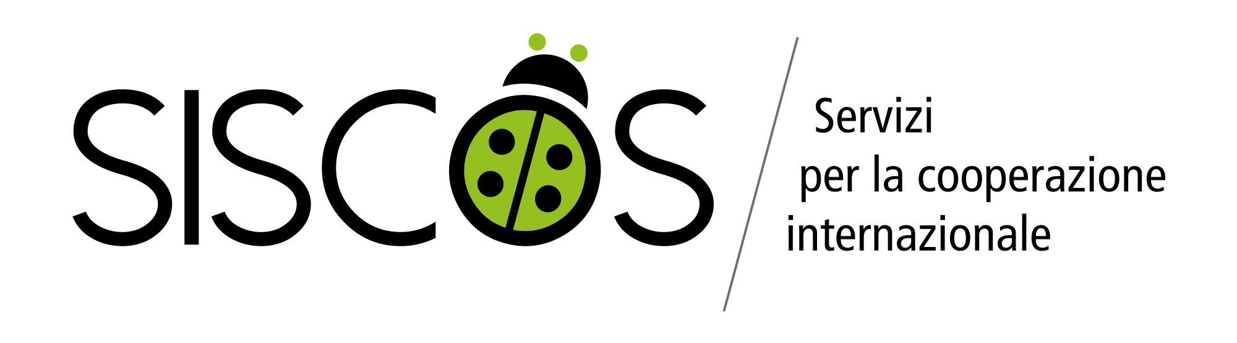
STATEMENT INDICATING CAUSES AND DYNAMIC OF ACCIDENT

Full Name of the Insured:

Injury happened on:

Place:

Description of the accident and of first treatments received:

